REVOLUTIONIZING EBITA REPORTING: TRANSFORMING DATA MANAGEMENT WITH 95-100% TIME SAVINGS AND RAPID INSIGHTS ACCESS OF A LEADING AUSTRALIAN-BASED NATURAL SPRING WATER PRODUCER

Our client is an Australian-based natural spring water producer. They specialize in crafting 100% Australian-made beverages and have a dedicated workforce of around 200 employees, with a revenue of $6 million. Aimed to empower their ERP Cloud and OTM Cloud users with advanced BI and analytics capabilities. The primary objective was to automate EBITA reporting and provide on-demand access to fresh reports, reducing the time spent from 30-40 hours a month. This initiative was driven by the need to transform their data management and reporting processes, ensuring faster, more efficient access to critical business insights.

**Team**: ETL and Data Analytics Development Team

**Customer Location:** Australia

**Technologies used in Project / Tech Stack**: Snowflake, Airflow, Azure VM, Power BI

**Duration:** 12 Months

**KPI Folks:** 10 resources

**Completion:** Completed.

**Project Solution:**

1. **Metadata-Driven Transformation:** Control Schema and metadata-driven processes streamlined job dependencies, reducing fragmentation and inefficiencies in data management.
2. **Line of Business (LOB) Analytics:** The introduction of comprehensive LOB analytics provided real-time insights across finance, procurement, costing, and inventory. To overcome performance bottlenecks, we custom-engineered an EBITA data model. Transformed data was centralized within KPI LOB Analytics Tables in Snowflake, serving as a unified data warehouse, while a Snowflake-based data lake facilitated the storage of structured and unstructured data, enhancing data accessibility and analytics, all secured by Azure's Client-Side Encryption (CSE) for data storage.
3. **Comprehensive Security and Access Control:** Pre-built security and governance framework was implemented, adhering to industry best practices. This framework ensured data quality, integrity, and resolved accuracy issues. Azure Active Directory centralized authentication and authorization, while Azure VNet and Azure Private Link provided secure network access, ensuring data protection during transfer and processing.
4. **Efficient ETL Framework:** The adoption of an efficient ETL framework, complete with Change Data Capture (CDC) support and the ability to handle slowly changing dimensions, addressed the challenges of manual analysis and ensured faster data processing. Additionally, KPI's Python-based Data Engineering Accelerator named "Data Extraction Framework for Fusion Cloud" was introduced to enhance the ETL process further.
5. **Optimized Data Models:** Snowflake-optimized data models, including dimensional and de-normalized models, accommodating structured data types
6. **Powerful Power BI Dashboards**: Pre-built dashboards, utilizing Power BI, were designed for efficient data visualization. These dashboards focused on LOB content, making data more accessible.
7. **KPI's Airflow++ Accelerator:** The introduction of KPI's Airflow++ Accelerator enabled better data tracking and orchestration, addressing data management inefficiencies with Real-time analytics and pre-built content for Oracle Fusion ERP and OTM

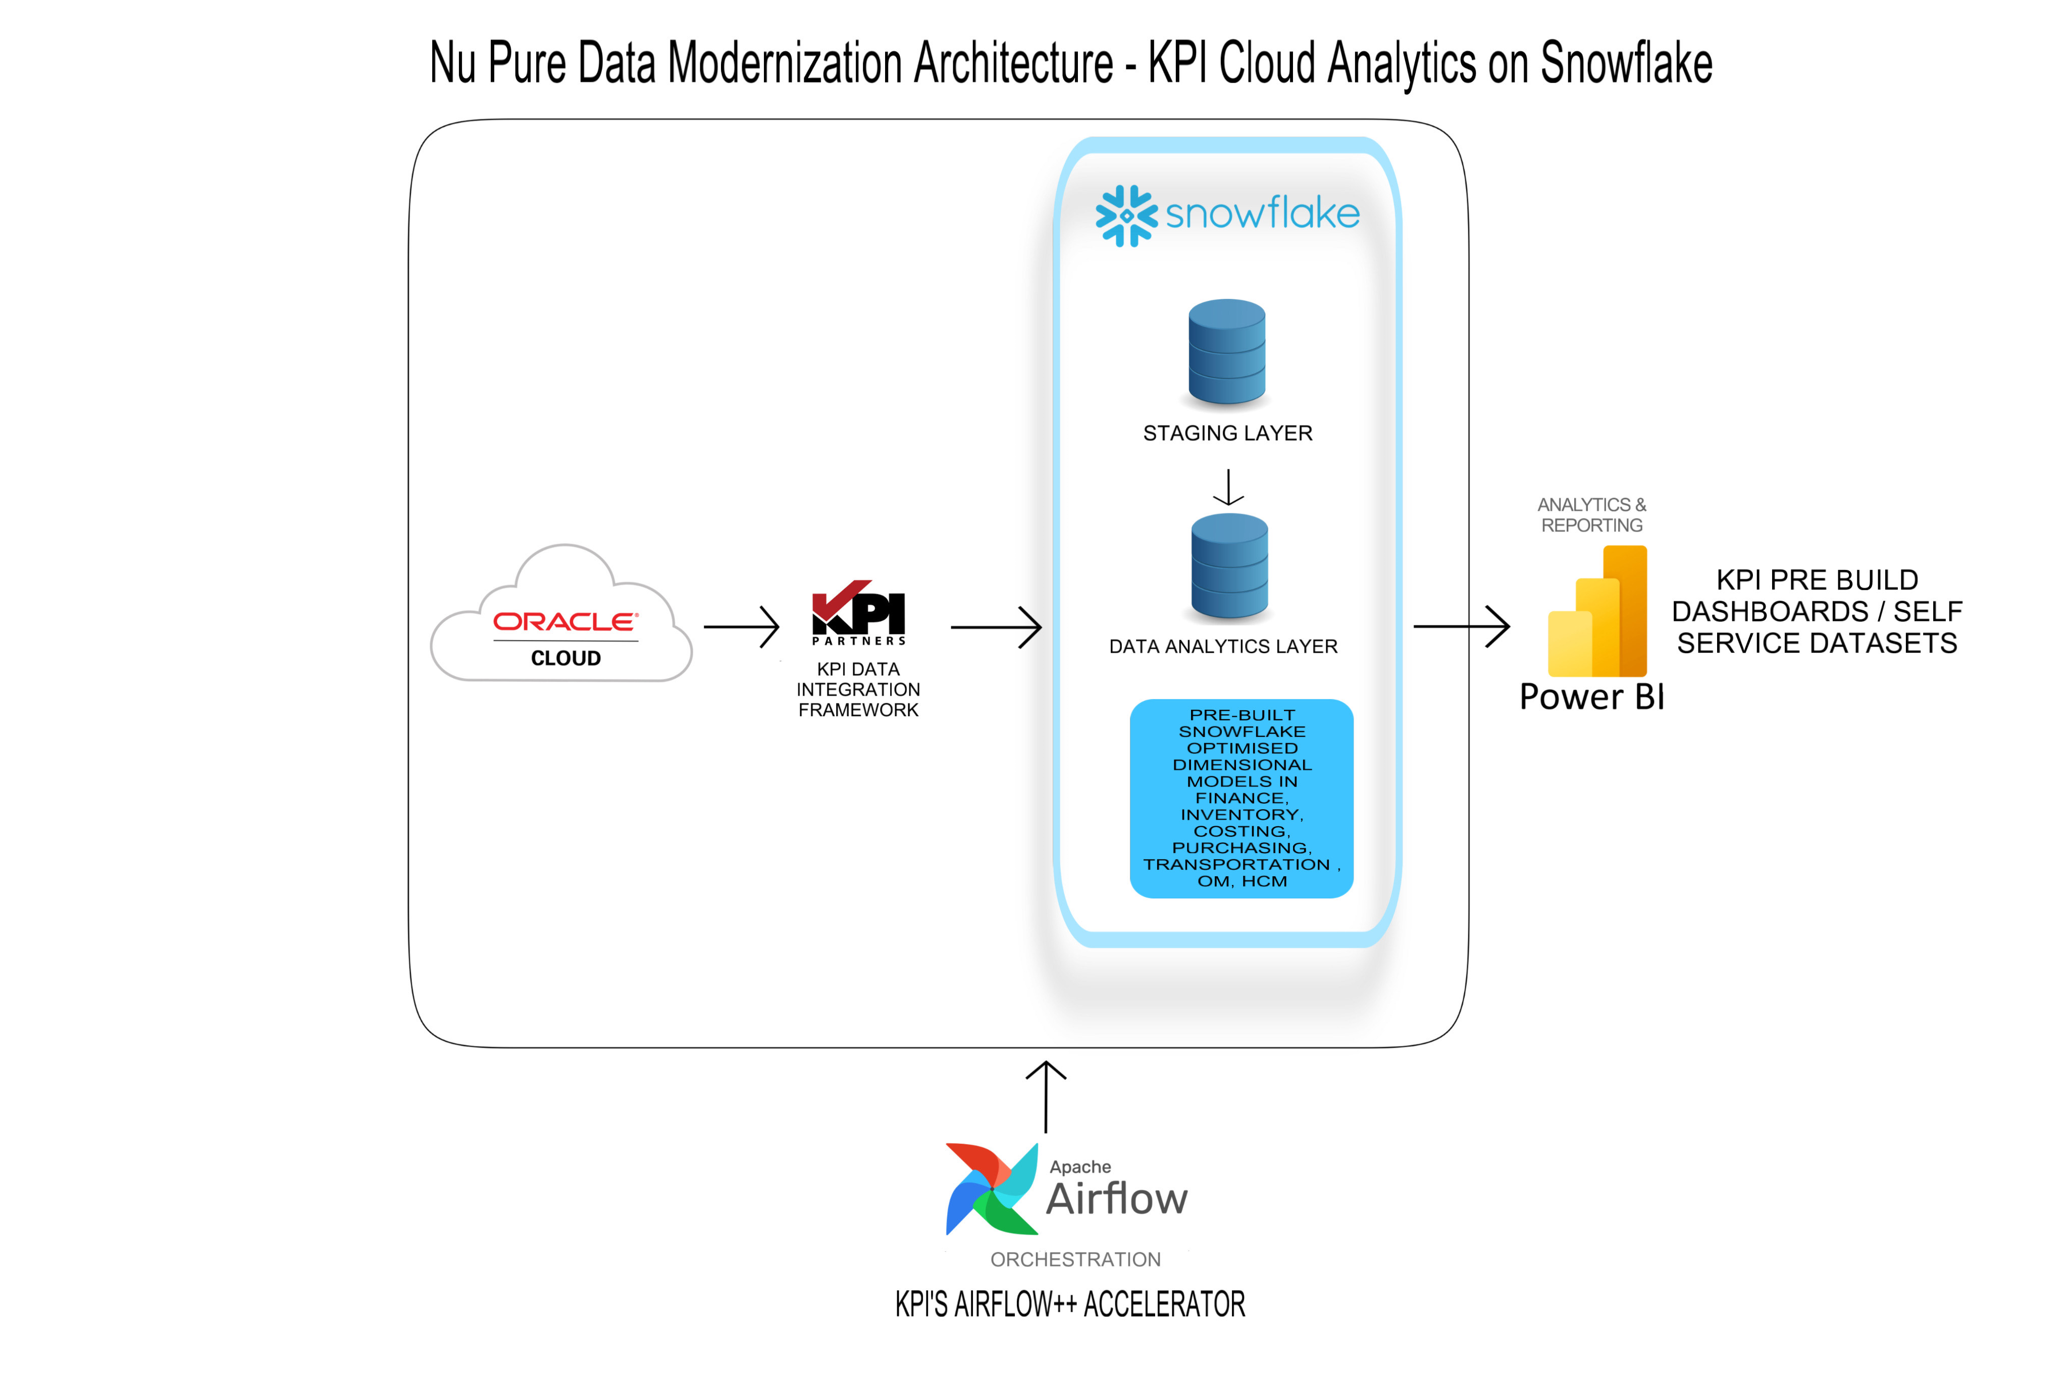

**ABOUT KPI PARTNERS:**

KPI Partners is a global strategic partner specializing in Analytics and Digital Transformation solutions, is at the forefront of driving innovation in data analytics, AI/ML/LLM, and digital transformation across diverse industries. Recognized by Gartner, KPI Partners has a

remarkable track record of serving over 300+ delighted clients, delivering excellence through 1000+ successful projects. Our global team of over 600 consultants strategically spans across North America, Latin America, and India, ensuring a comprehensive reach to meet your business needs.

If you’re on a journey of growth and innovation, and you’re seeking a global partner in Data Analytics, AI, and Digital Transformation, let’s connect to explore how KPI Partners can

elevate your business to new heights.

To learn more about our offerings, visit <https://www.kpipartners.com/> or reach out to us at [info@kpipartners.com](mailto:info@kpipartners.com).